DEERWALK INSTITUTE OF TECHNOLOGY
Tribhuvan University
Faculties of Computer Science

Bachelor of Science in Computer Science and Information
Technology
(BSc. CSIT)
Course: Computer Architecture (CSC-213)
Class of 2027/Semester: III
A Lab Report On:
Number System
Submitted to:
Er Kiran Bagle
Faculty, Department of Computer Science
Submitted by:
Name: Shaurav Bhandari
Roll No: 1333

Experiment 1
TITLE: Data Representation

OBJECTIVES:
- To illustrate the concept of data representation.
THEORY:
Data Representation:
Data representation refers to the methods and formats used to store, process, and transmit data so it can be understood and utilized effectively by computers or humans. It is fundamental in fields like computing, data analysis, and communication systems. In computing, data are stored in digital formats that can easily be handled by electronic circuitry. There are various forms of representing data, some of which are listed below:
- Binary Number System: It represents numbers using a series of 0s and 1s. It has base 2.
- Hexadecimal Number System: It represents numbers using decimal and alphanumeric numbers(0 to 9 then A to F). It has base 16.
- Octal Number System: It represents numbers using decimal numbers from 0 to 7. It has base 8.
- 1’s((r - 1)’s) and 2’s(r’s) complement: This number system is used to represent negative or signed numbers. 1’s complement inverts all bits in the numbers while 2’s complement uses the result of 1’s complement and then adds 1 to the result.

PRACTICAL IMPLEMENTATION

TASK 1: NUMBER SYSTEM CONVERSIONS
ALGORITHM:
- Start
- Define a function to find for an integer, it calculates,
  - It’s binary equivalent
  - 1’s complement of the calculated binary equivalent
  - 2’s complement of the same binary number
  - It’s hexadecimal equivalent
  - It’s octal equivalent
- Input a number
- Calculate the equivalent values of the given integer
- Print the results.
- Stop

SOURCE CODE:
#include <stdio.h>
#include <conio.h>

void Binary(int num, int bits){
int k;
for (int i = bits - 1; i >= 0; i--)
{
k = (num >> i) & 1;
printf("%d", k);
}
}

int main(int argc, char const *argv[])
{
int number, bits;
printf("Enter the number:\n");
scanf("%d", &number);
printf("Enter the number of bits for binary representation:\n");
scanf("%d", &bits);
printf("The HexaDecimal Equivalent of the given number is %x", number);
printf("\nThe Octal Equivalent of the given number is: %o", number);
printf("\nThe binary equivalent of the number is: ");
Binary(number, bits);
printf("\nThe 1's complement is: ");
Binary(-number - 1, bits);
printf("\nThe 2's complement is: ");
Binary(-number, bits);
return 0;
}

OUTPUT:
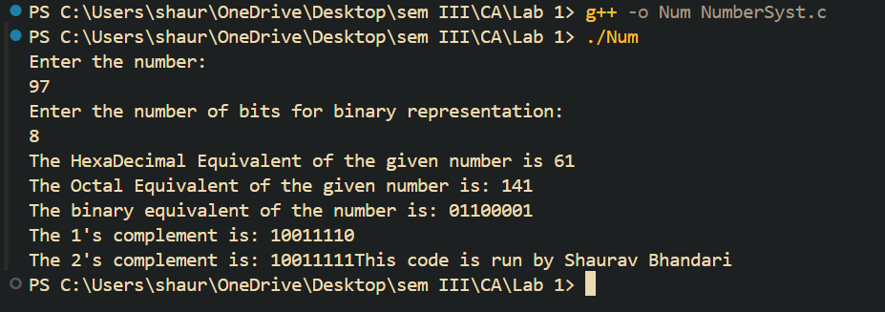

TASK 2: One’s and Two’s Complement using Bitwise Operators
SOURCE CODE:
#include <stdio.h>
#include <string.h>

int onesComplement(int num) {
int bitNum = 4; // Default = 4 bits
for (int i = 0; i < bitNum; i++) {
num ^= (1 << i); // Invert each bit
}
return num;
}

void twosComplement(char *binary) {
int length = strlen(binary);
int firstIndex = -1;

for (int i = length - 1; i >= 0; i--) {
if (binary[i] == '1') {
firstIndex = i;
break;
}
}

if (firstIndex == -1) {
return; // No '1' found, already zero
}

for (int i = firstIndex - 1; i >= 0; i--) {
binary[i] = (binary[i] == '0') ? '1' : '0';
}
}

int main() {
char binaryNum[5]; // 4 bits + null terminator
printf("Enter 4-bit Binary Number:\n");
scanf("%s", binaryNum);

if (strlen(binaryNum) != 4 || strspn(binaryNum, "01") != 4) {
printf("Invalid input. Please enter a 4-bit binary number.\n");
return 1;
}

int decimalNum = 0;
for (int i = 0; binaryNum[i] != '\0'; i++) {
decimalNum = decimalNum * 2 + (binaryNum[i] - '0');
}

printf("\nOriginal Binary Number = %s\n", binaryNum);

// Calculating one's complement
int onesComp = onesComplement(decimalNum);
printf("One's complement = ");
for (int i = 3; i >= 0; i--) {
printf("%d", (onesComp >> i) & 1);
}
printf("\n");

// Calculating 2's complement using the 1's complement value above
int twosComp = onesComp + 1;
printf("2's complement = ");
for (int i = 3; i >= 0; i--) {
printf("%d", (twosComp >> i) & 1);
}
printf("\n");

char longBin[] = "1010110";
printf("\n2's complement value calculated using the function:\n");
printf("Original value = %s\n", longBin);
twosComplement(longBin);
printf("2's complement = %s\n", longBin);

return 0;
}
OUTPUT:
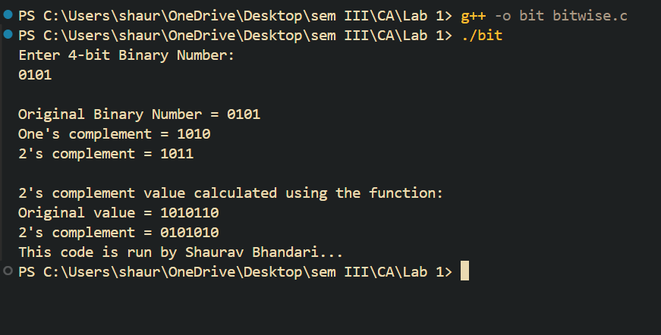
CONCLUSION:
Hence, the experiment of using different number systems and their conversions was implemented successfully using the C-Programming Language. The implementation demonstrates the practical application of bit-wise operations, string manipulations, and arithmetic operations to perform conversions between different number systems.

Experiment 2
TITLE: Data OverFlow

OBJECTIVES:
- To illustrate the concept of data overflow.
THEORY:
Data Overflow:
Data overflow in computer programming occurs when the result of an operation exceeds the maximum value that can be represented by the data type being used. For example:
- If you store a number(say length is 9-bits) larger than the maximum value a variable can hold(say 8-bits), the extra bits are lost and the value ‘wraps around’ to the smaller number.
- This is a particularly common in integer arithmetic, where the number of bits used to represent the value is fixed.
The condition for overflow is:
((AS == BS) and (As == RS) || (AS !=BS )
{
NO overflow, display result;
}
PRACTICAL IMPLEMENTATION
ALGORITHM:
- Input:
  - Two binary numbers: A and B of the same length.
  - Any operation to be performed on the inputs
- Output:
  - True, if Overflow, false otherwise.
- Steps:
- Start
- Perform the operation
- Extract the sign bit(most significant Bit(MSB)) of A, B and result R.
- Compute the carry into the sign bit position during the operation. This can be done by observing the second MSB to the MSB.
- Compute the carry out of the sign bit position during the operation. This is the carry generated from the MSB.
- If carry_out XOR carry_in == 1, overflow has occurred.
- If overflow has occurred, return True; Else False.
- Stop.
SOURCE CODE:
#include <stdio.h>

int main(int argc, char const *argv[])
{
int A, B, result;
int signA, signB, signResult;
//get the inputs
printf("Enter the two 4-bit binary numbers...\n");
scanf("%d %d", &A, &B);
// perform addition
result = A + B;
// Extract the sign Bits. In this case the 4th bit
signA = (A >> 3) & 1;
signB = (B >> 3) & 1;
signResult = (result >> 3) & 1;
if ((signA == signB) && (signB != signResult) || (signA != signB))
{
printf("\nOverflow detected! The result is: %d\n", result);
}
else
{
printf("\nNo overflow! The result is: %d\n", result);
}
return 0;
}

OUTPUT:
